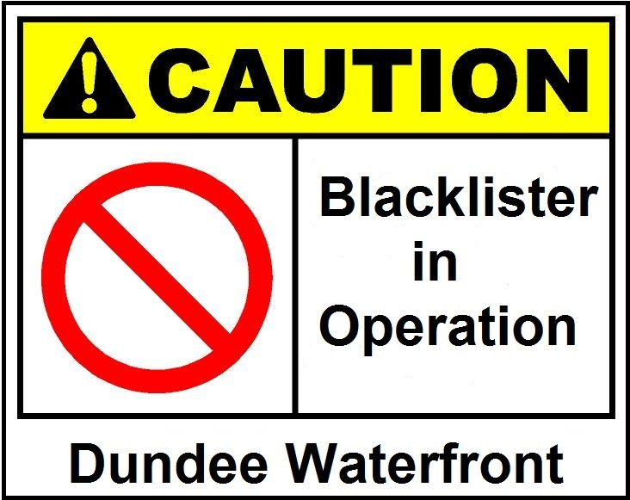

Speakers include: Jim McGovern MP, Neil Findlay MSP, John McAllion…and more
UNITE TRANSPORT FROM GLASGOW
Outward: Leaves George Square 08:00 PROMPT
Return: Leaves Dundee approx. 13:30

PLACES LIMITED
To reserve your seat contact
Jim Harte
Text: 07817313308
Email: james.harte2@btinternet.com

